



Document Subtitle
Document Title Goes Here
Author(s)  John Doe | Department  Implementation | Effective Date  18 May 2026 | Version  1.0

Table of Contents

Heading 1 4
Heading 2 4
Heading 3 4
Introduction 5

Revision History
Date | Version | Description
08 July 2025 | 1.0 | Lorem ipsum dolor sit amet
10 July 2025 | 1.1 | Lorem ipsum dolor sit amet
11 July 2025 | 1.2 | Lorem ipsum dolor sit amet

Heading 1

Heading 2

Heading 3
Lorem ipsum dolor sit amet, consectetur adipiscing elit, sed do eiusmod tempor incididunt ut labore et dolore magna aliqua. Ut enim ad minim veniam, quis nostrud exercitation ullamco laboris nisi ut aliquip ex ea commodo consequat. Duis aute irure dolor in reprehenderit in voluptate velit esse cillum dolore eu fugiat nulla pariatur.
Excepteur sint occaecat cupidatat non proident, sunt in culpa qui officia deserunt mollit anim id est laborum.
Column 1 | Column 2 | Column 3 | Column 4
Row 1 | Lorem ipsum
Row 2
Row 3

Bulleted list
- Sed ut perspiciatis unde omnis amet, consectetur adipiscing elit, sed do eiusmod tempor incididunt ut labore et dolore magna aliqua. Ut enim ad minim veniam, quis nostrud exercitation ullamco laboris nisi ut aliquip ex ea commodo consequat. Duis aute irure dolor in reprehenderit in voluptate velit esse cillum dolore eu fugiat nulla pariatur
- iste natus error sit voluptatem
- accusantium doloremque

Numbered list
- Sed ut perspiciatis unde omnis
- iste natus error sit voluptatem
- accusantium dolorem

Second page sample from existing document.

Introduction
This document outlines the updated process for using Zendesk as an Agent for Support Tickets
As part of our efforts to streamline support operations and improve ticket response times, we have now activated auto-assignment for incoming tickets within Zendesk.
Tickets are now distributed using a round robin method. This means the next ticket will be assigned to the agent who has gone the longest without a ticket on the relevant channel/queue.
To ensure fairness and efficiency in this process, it is essential that everyone manages their availability status properly.

What You Need to Do:
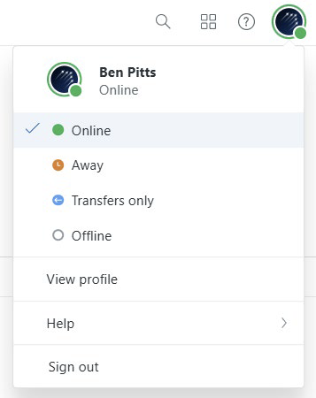 | - At the start of your shift: Set your Zendesk status to Online.  - During lunch, pre-scheduled meetings or extended breaks: Set your status to Transfers Only or Offline to avoid receiving tickets during that time.  - At the end of your shift: Make sure to go Offline or Close all Zendesk Agent screens entirely.



TrustFlight United Kingdom  UK +44 (0) 330 229 0219  London  22 Lavington Street  London, SE1 0NZ  Bracknell  The Western Centre  Bracknell, Berkshire, RG12 1RW  Doncaster  The National Safety & Security Academy, First Avenue  Finningley, Doncaster, DN9 3RH  Luton  Basepoint, Great Marlings  Luton, Bedfordshire, LU2 8DL | TrustFlight North America  US & CA +1 (844) 784 9836  Vancouver  Commerce Place, 1110 – 400 Burrard St  Vancouver, BC, V6C 3A6  Houston  2408 Timberloch Place, Suite A5  The Woodlands, TX 77380 | TrustFlight Jersey  UK +44 (0) 330 229 0219  Jersey  Ground Floor, Forum 4, Block 3  Grenville Street, St Helier, JE2 4UF  Jersey, Channel Islands
sales@trustflight.com | trustflight.com

